Minutes of Shapinsay Development Trust
A.G.M.
2nd September 2018 at 19:30
In the Community Centre
- Apologies. Jim Hepburn
- Approval of the Minutes of the A.G.M. on 3rd September 2018
Proposed Simon Meason, seconded Graham Rendall
- Matters Arising.None.
- Report of accounts. The Draft accounts were presented by Davie Campbell who explained that the figures were final but more notes would be added once the full audit had been completed.
- Approval of accounts They were approved by the members.
Proposed Annett Kirkpatrick seconded Richard Lawrence.
- Chairs Report.
Another busy year for the trust has passed since the last AGM. 2019 has seen a number of changes at SDT with a few changes in the board, new memberships of trustees and the addition of a new employee.
2018 was dominated by the installation of the hydrogen production facility up at the turbine site and I am pleased to inform you the equipment has been producing gas during its commissioning phase which is nearing completion. 2019 for the trust has been dominated by two of the most long standing issues facing the community Housing and well-being.
With the opportunity of joint working with other islands in Orkney to fund a well-being officer post here on Shapinsay we were lucky enough to secure an additional place within the project application to secure Allison’s post here. We were very fortunate to get the additional post allocated to Shapinsay as the other Islands involved made up the funding contribution required to allow us to participate in the project.
It was good to see that level of cross working between independent Island development trusts and has been very much appreciated by SDT.
Housing has been the main discussion point since last year’s AGM and since then the SDT has undertaken a series of community consultations most recently last week’s postal ballot which gave the level of participation and response the relevant funders require to see before entering into any future funding applications.
The SDT board, as well as other Island groups, felt that since the issue of housing had been in the development plan for so long it was important to get as much feedback as possible on the ballot and not just the binary yes no result. I am happy to say this level of engagement was rewarded in a clear response from you the community not only clarifying the thoughts of those in favour but also the concerns of those voting against the proposal of a community housing project. I believe that many of those concerns can be addressed in the next stages of the project and that when we hear from Luke he can allay some of the other concerns raised.
Transport still accounts for the largest part of the trusts day to day operations with the use of the electric car and OOH boat increasing since last year. It is good to see these services being used by the community and the increase in popularity. The addition of other service providers and additional drivers has allowed these services to continue throughout the year for the first time since they began.
The SWAP fund continues being used well by a variety of groups and individuals in the community which is great to see.
The Boathouse continues to host a variety of local groups and visitors throughout the week which is putting the building to good use.
Financially the trust remains in good health with the revenue from Whirly continuing to support the trusts core expenses and activities with additional funding being brought in through external funding bodies.
On a personal note this is my 6th consecutive year on the SDT board and as such it is my final, as I need to stand down from the board as per the mem. & arts. of the constitution. The previous 6 years have seen many changes both in the where and how the SDT operate. With the opening of the Boathouse as a base for the trust to operate from it has flourished into the venue for many new groups and a meeting place for visiting stakeholders and funders too. In the past 2 years as chair I have had the privilege to represent SDT at a number of meetings in Orkney, Edinburgh and last year in Brussels. This year we have hosted Euro news, CNN, BBC R4 and the Washington Post. They all come to see what this small Island is doing for its self. These meetings remind me that despite our size we are seen as a very forward looking pro-active community group across a number of activities. A number of people have pointed out we run and maintain a large Electricity power generator, host a Hydrogen production site, co-ordinate Islander transport by sea and by road, provide and manage a venue and act as a funding body.
All these activities are only possible because of the work of our staff, commitment of our volunteer board members and the participation of the wider community in contributing to our development plans. I must thank the staff and Board for their patience with me in my time on the board and especially as chair; I do not have a job which allows me to read or write emails during normal work hours or always hear a phone ringing in my pocket. So thank you all very much for your help, criticisms, patience and support throughout my time on the board.
The next year looks to be another busy one for SDT and I wish it every success in the future.

- Appointment of Auditor. It was proposed we continue with Orcadia.JB & Colin l
- Appointment/Election of Directors. Steven Bews stood down after 6 years.
Andy More had stood down earlier this year leaving 2 elected director spaces on the board.
Martyn Garret was proposed by Lorna Foubister & seconded by Helen Jones
Adrian Bird was proposed by Graham Rendall and seconded by Simon Meason.
All agred

- AOB. As there was no other business the formal meeting was closed.
Tea Break

- Housing Result
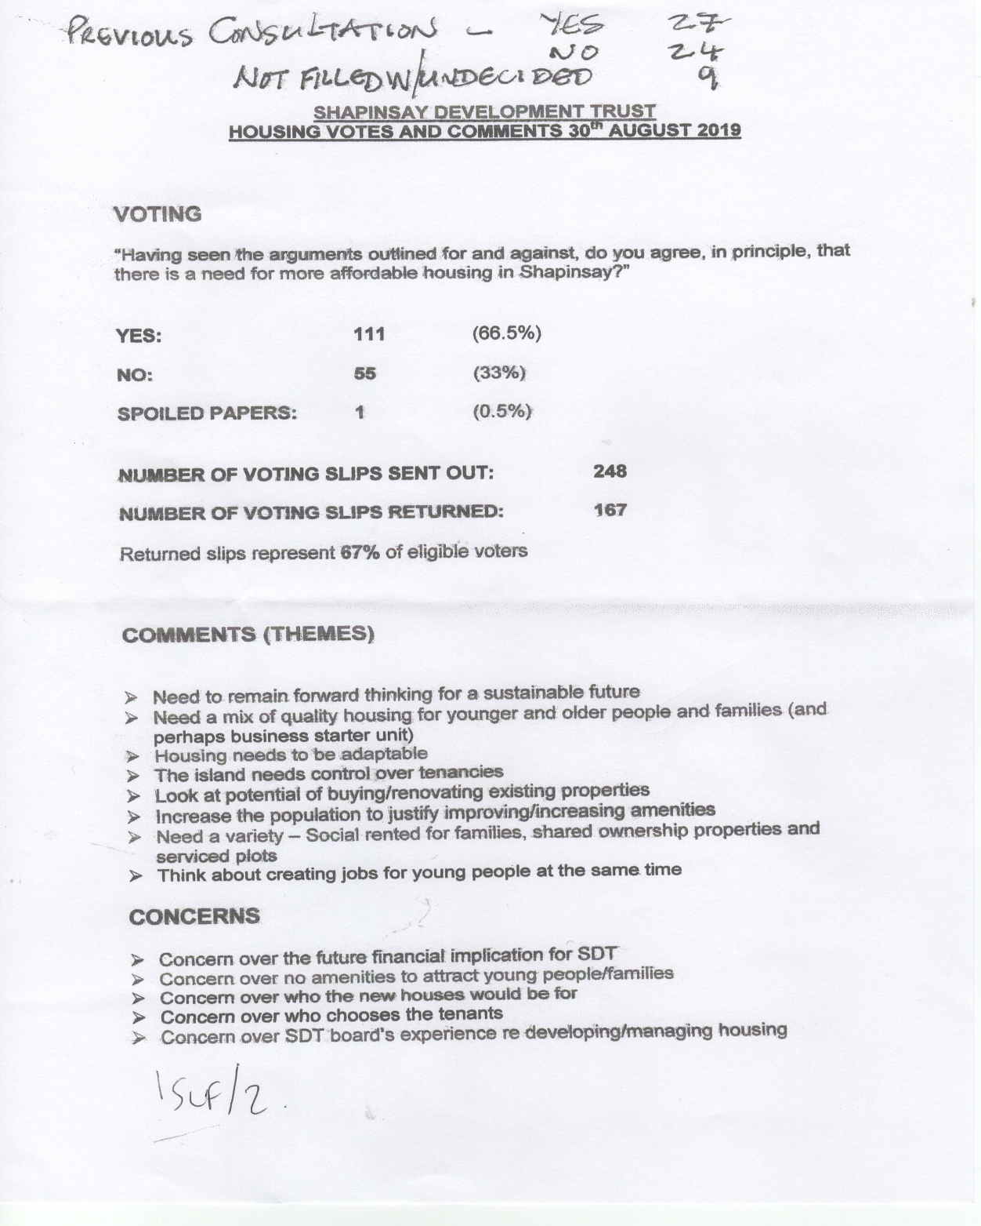

- Luke Frazer. From OIC housing dept. took questions from the floor.

- Hydrogen
There was then a short meeting of the new Board to welcome Martyn and Adrian and appoint officers.
Chair, Jean Coomber. Vice Chair, Richard Lawrence. Treasurer, JB Bady.
Date for next board meeting is 12th September 2019 at 6pm.

